35 Questions Solved with SQL-PostgreSQL

- Select the first_name and the last_name of each actor. This query should result in selecting 2 columns.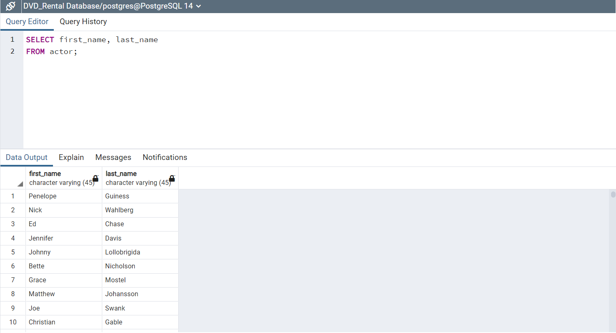
- Select the full name of the actor. This query should result in 1 column.
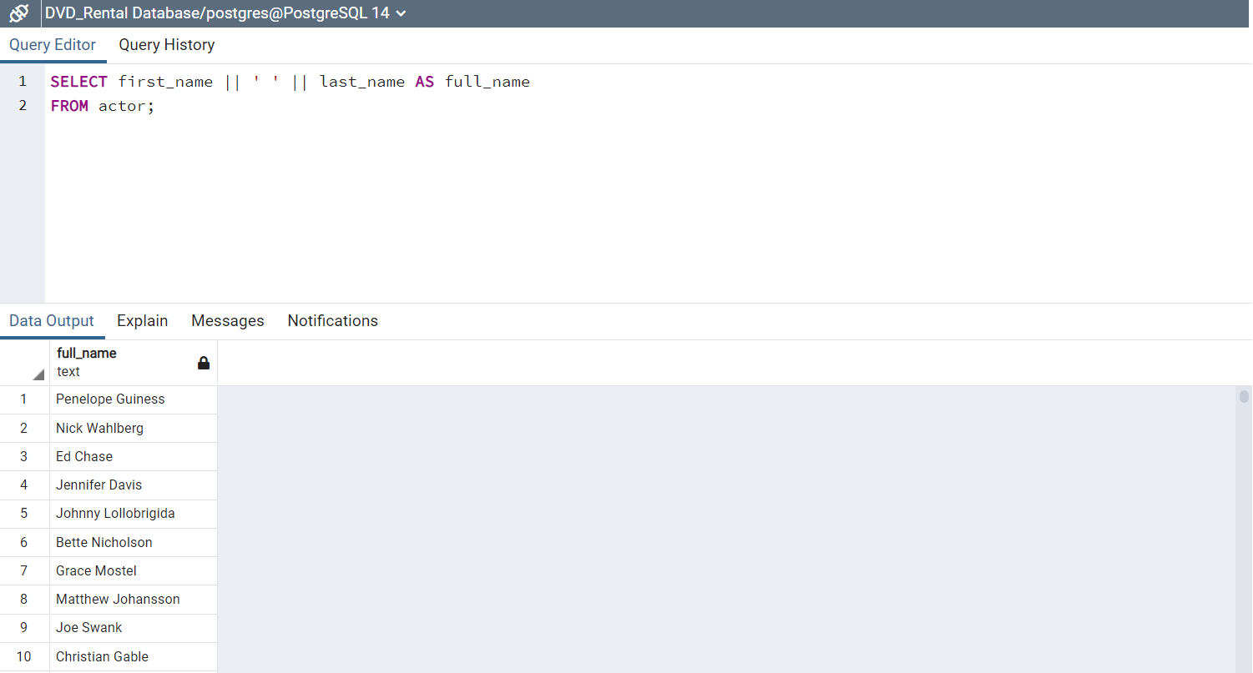
- Select the actors that have names starting with a ‘D’.
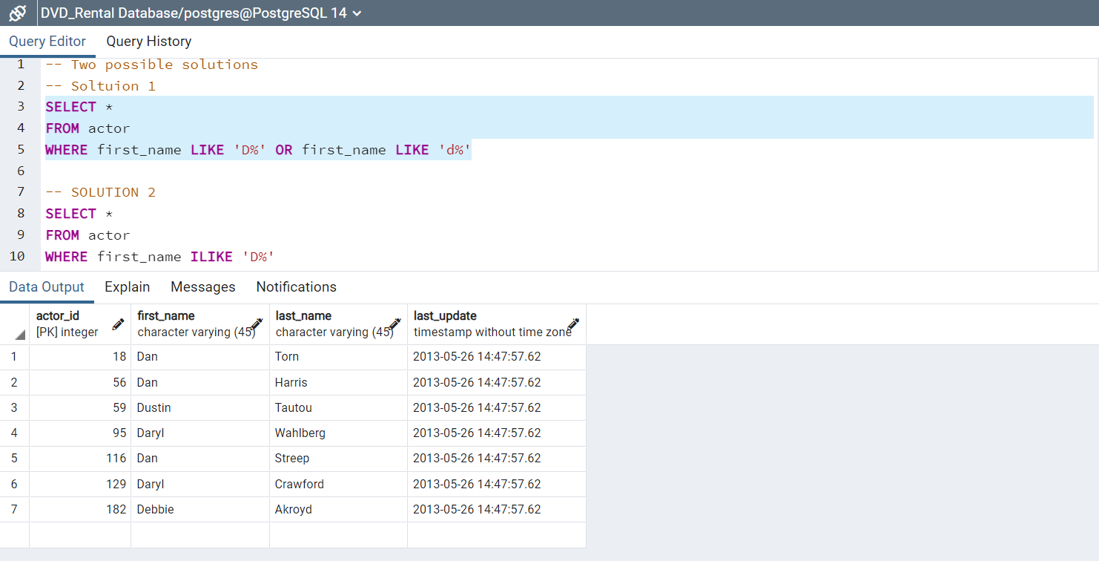

- Select all the actor information sorted by the first name ascending. 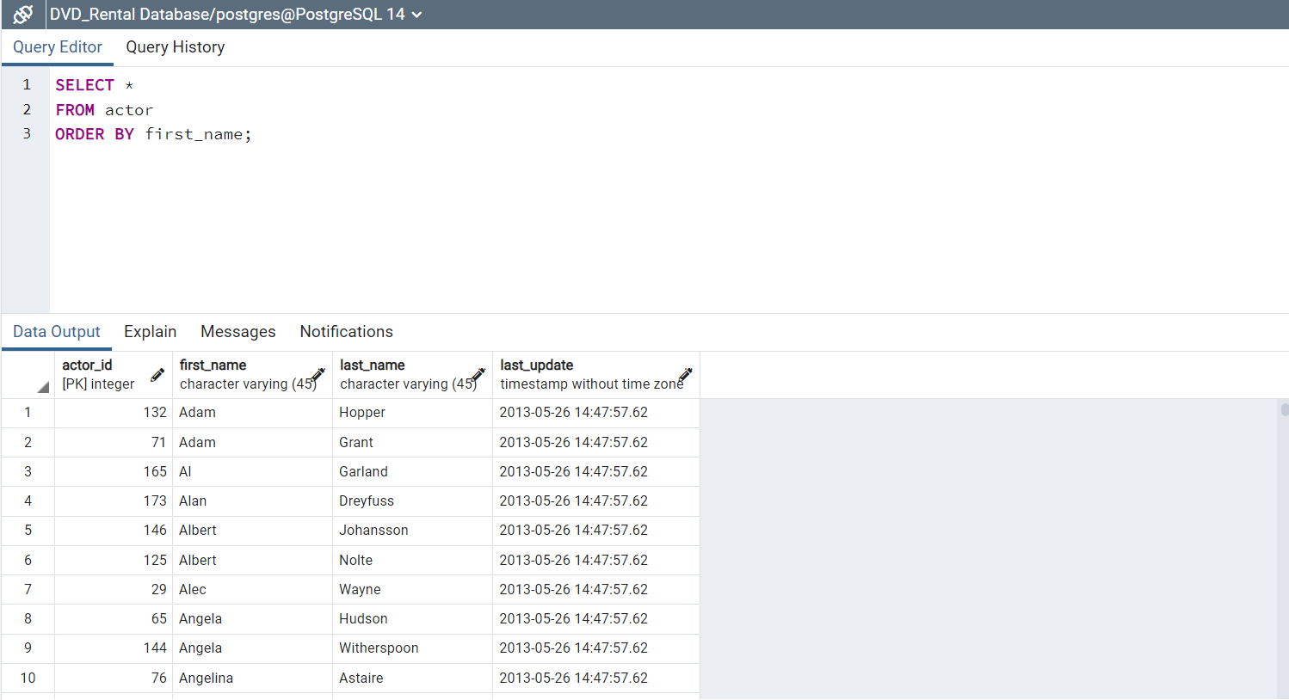

- Count the unique actor’s first names
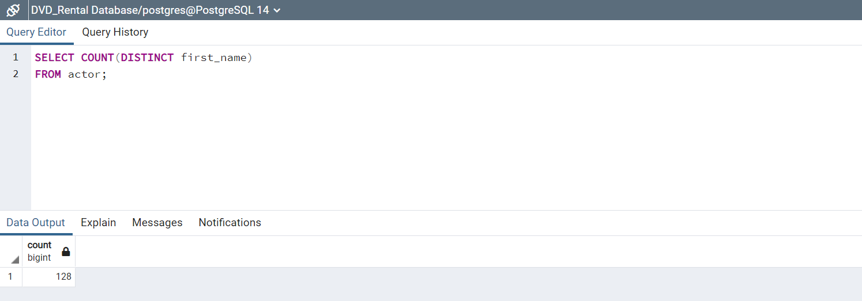
- how many unique full names do we have of those actors
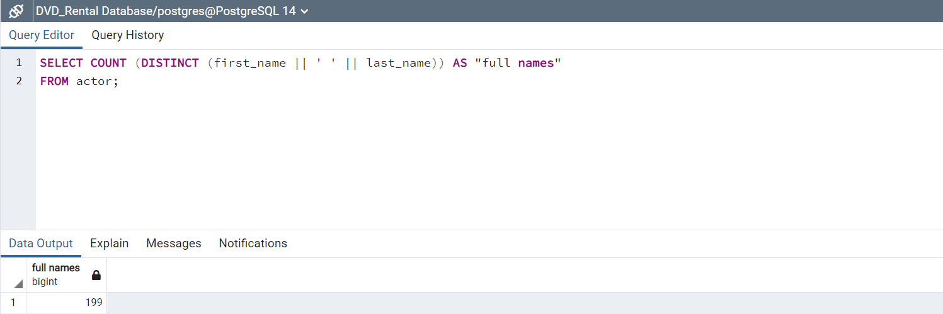

- Count the number of films based on their rental duration. rental_duaration in the film table referes to how long is the DVD allowed to be rented.
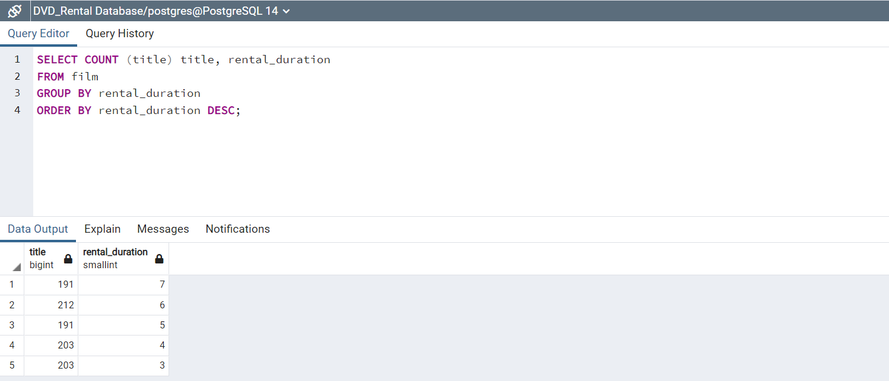
- Select the maximum replacement cost
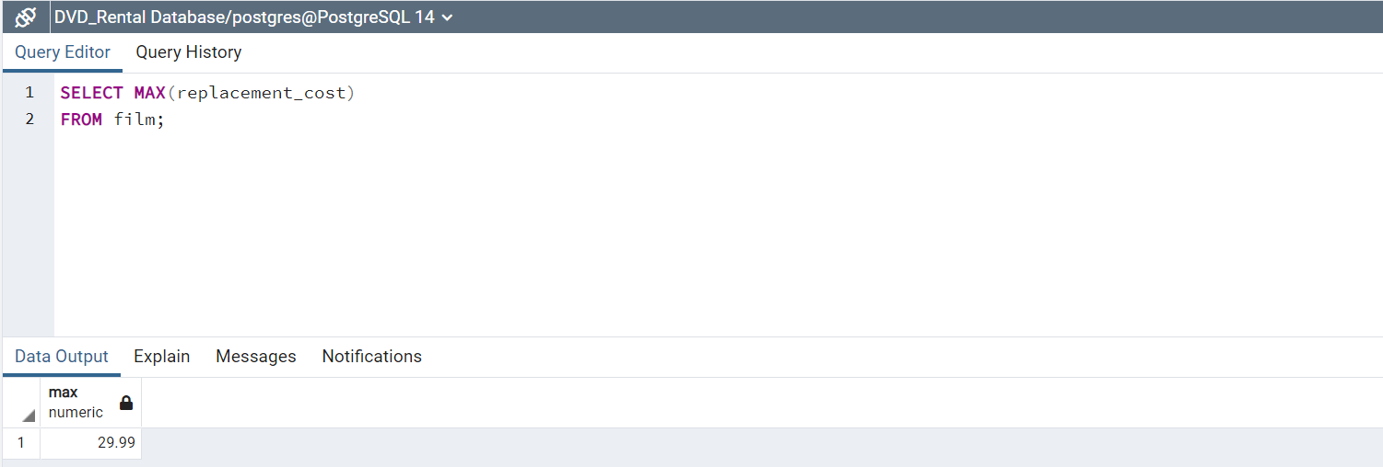
- Select the titles of the movies that have the highest replacement cost.
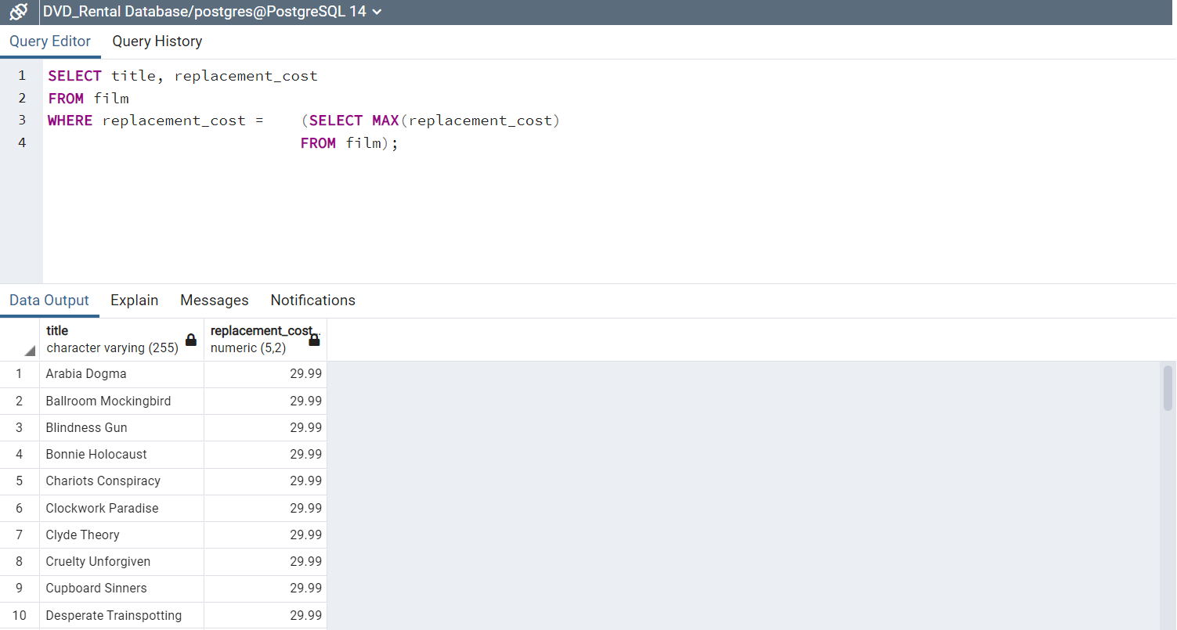

- Select the unique different ratings for the movies in the film table.
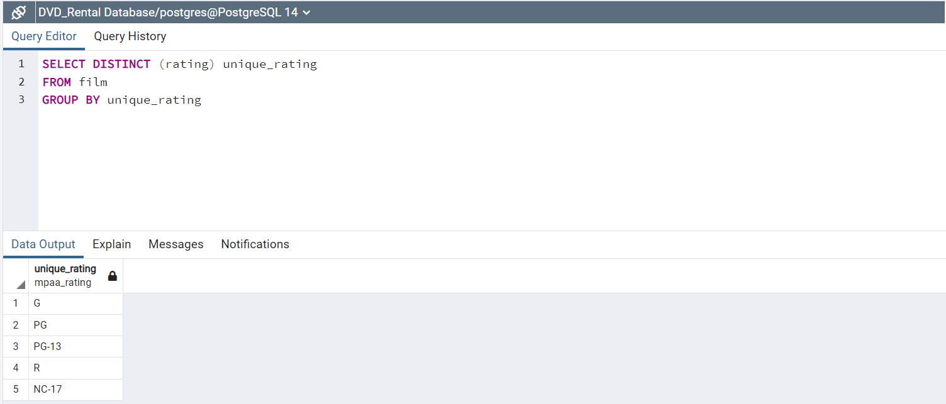
- Select the number of movies available under each rating.
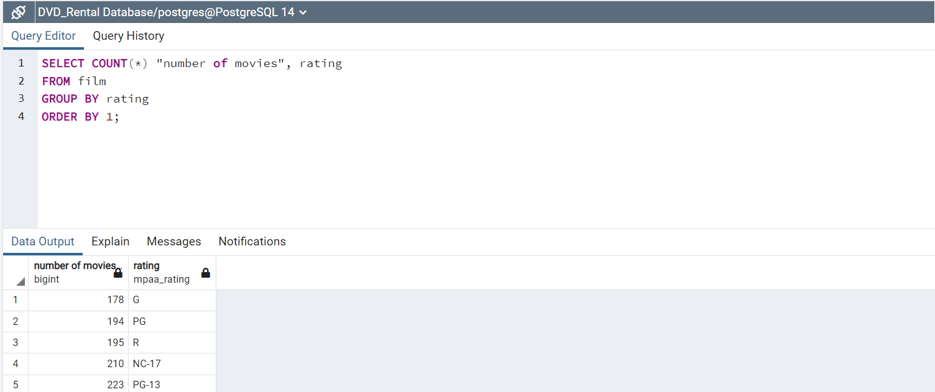
- Change the movie language for the first 20 movies from English language to Italian.
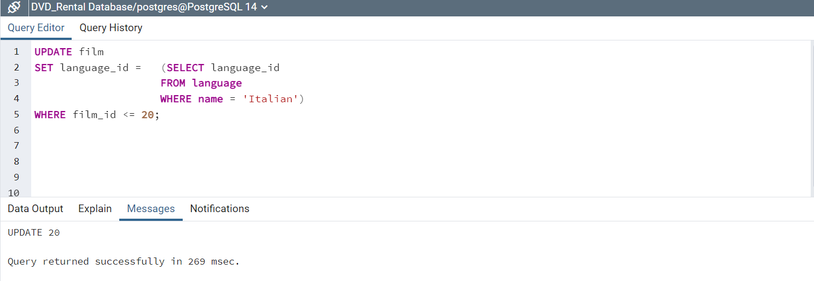
- Select the count of movies grouped by language
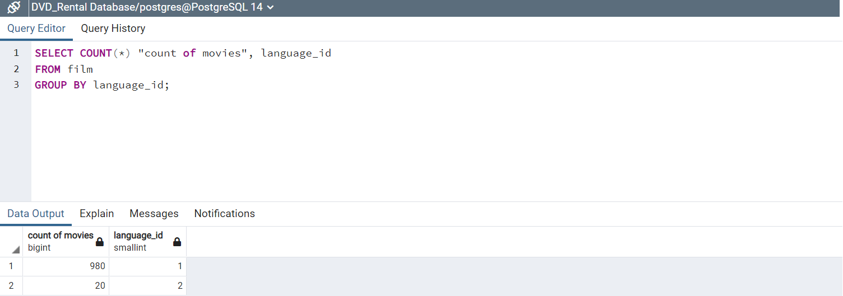
- Select the language that most of the movies belong to.
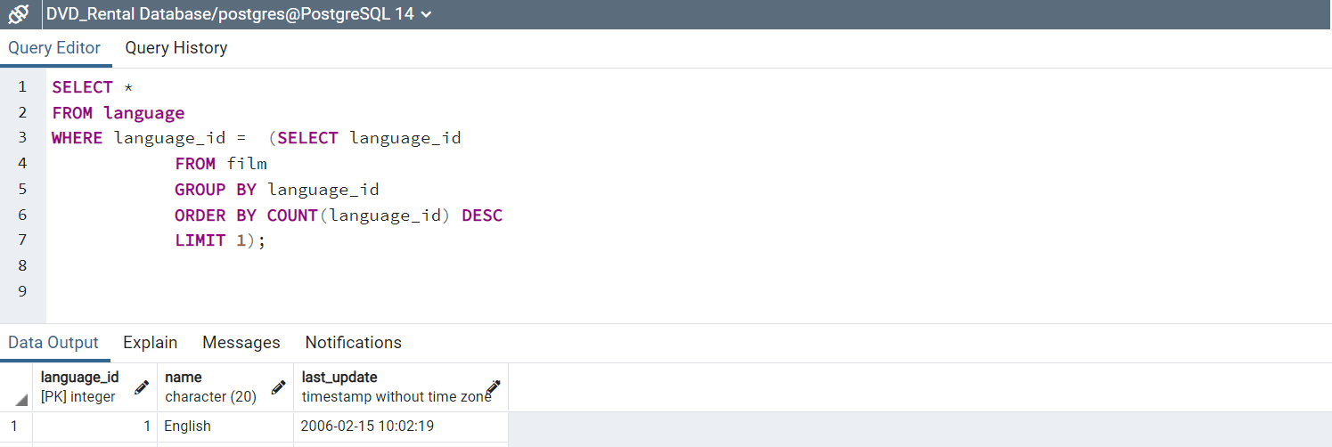
- Select movie titles and replacement costs and ratings along with the average replacement cost for movies in the rating that the movie belongs to.
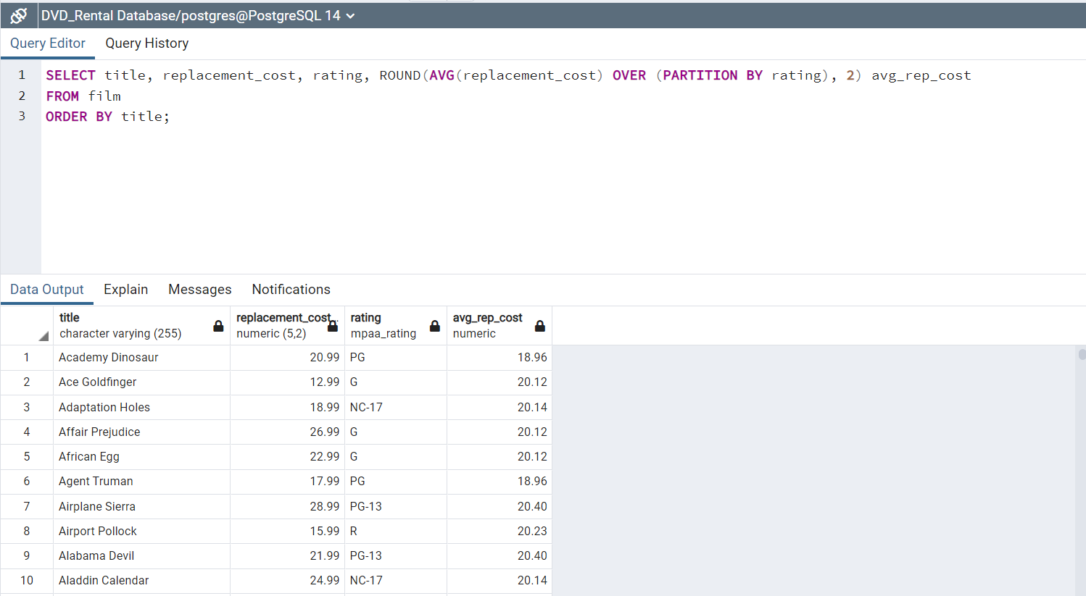
- Select the ratings and average replacement cost for Italian movies.
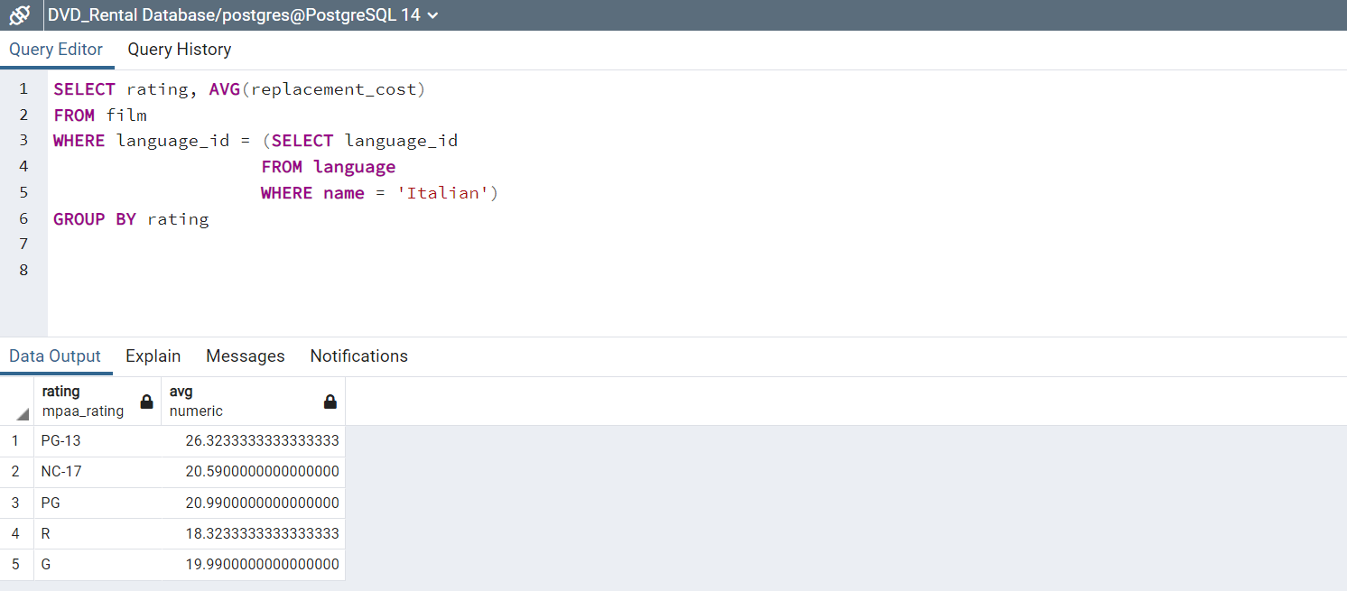
- Count the movies that has the maximum replacement cost in the film table.
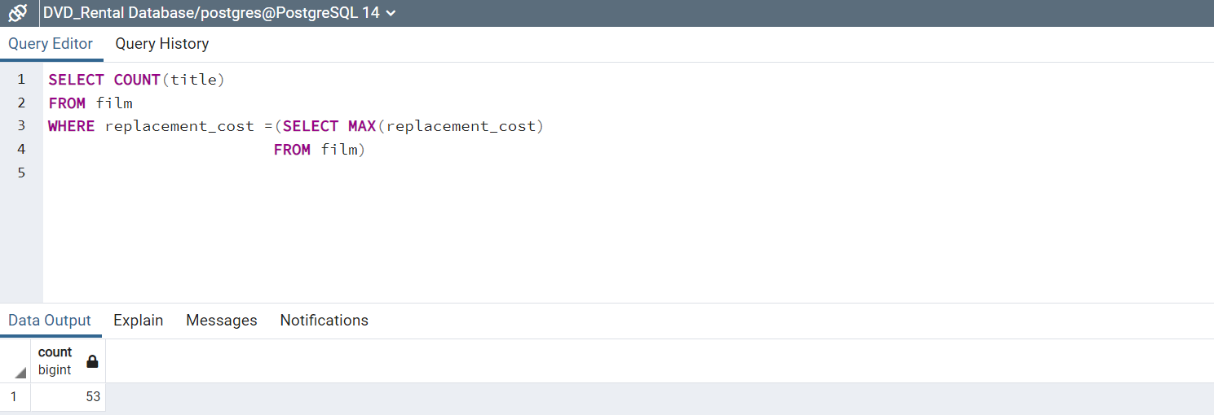
- Count the number of movies we have for each language in the film table. (Note we have movies that are in English and Italian languages only)
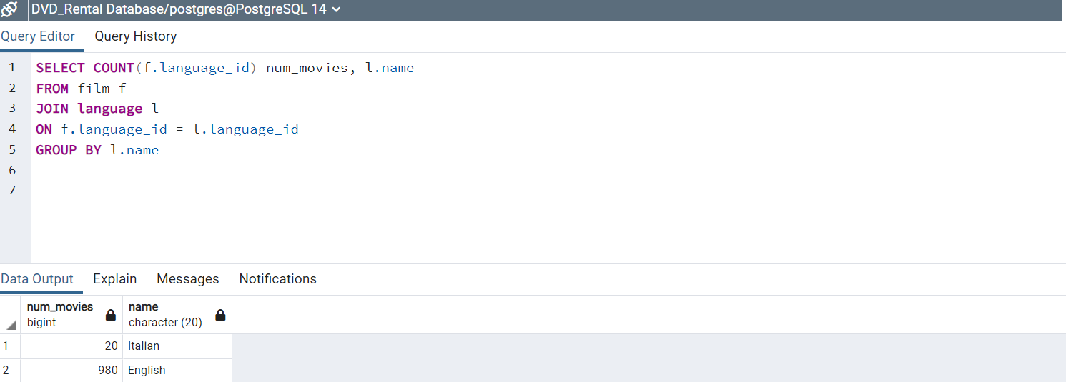
- Count the number of movies exist under each of the 6 languages that exists in the language table (English, Italian, French, Mandarine, Japanese and German).
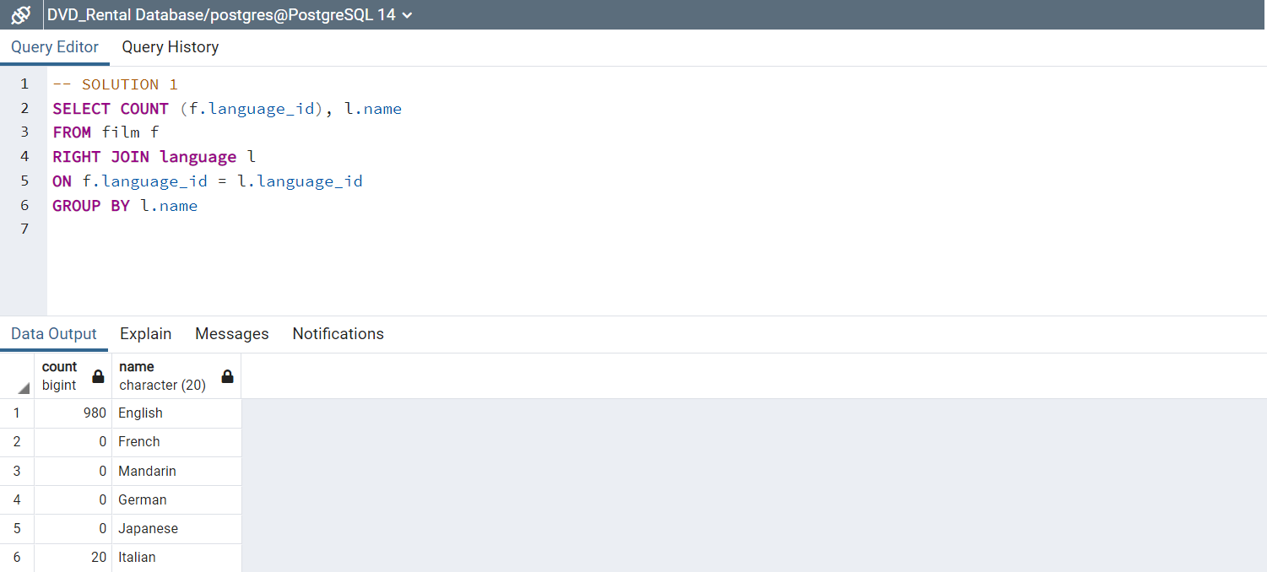
- Count the number of movies exist under each of the 6 languages that exists in the language table (English, Italian, French, Mandarine, Japanese and German).

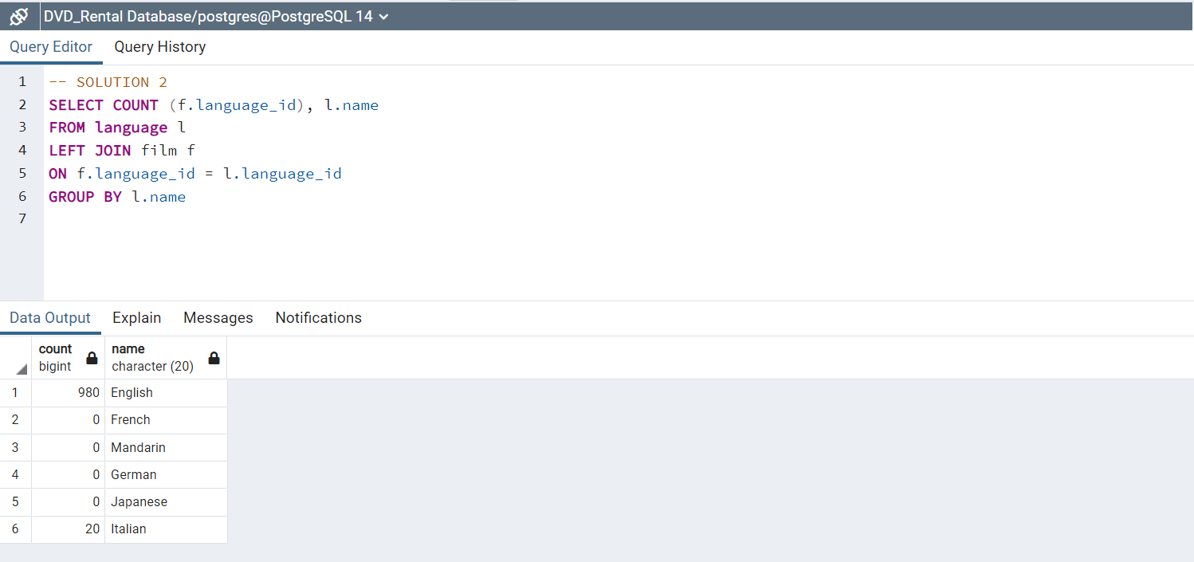

18) Count the number of movies grouped by language_id and rating and sort the results by the language id ascending.
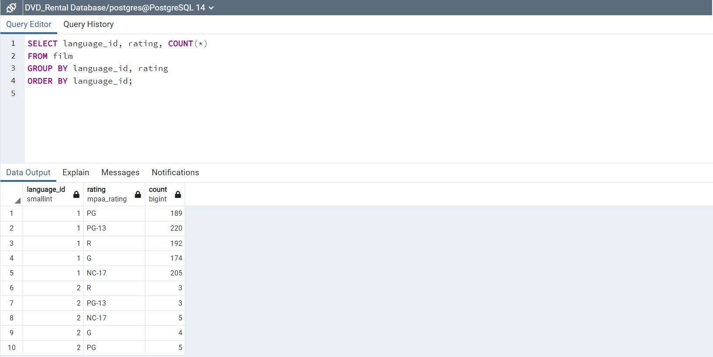
19) Select the language_id, rating and count the number of movies under each language_id and rollup on language_id and rating then sort by the language id.
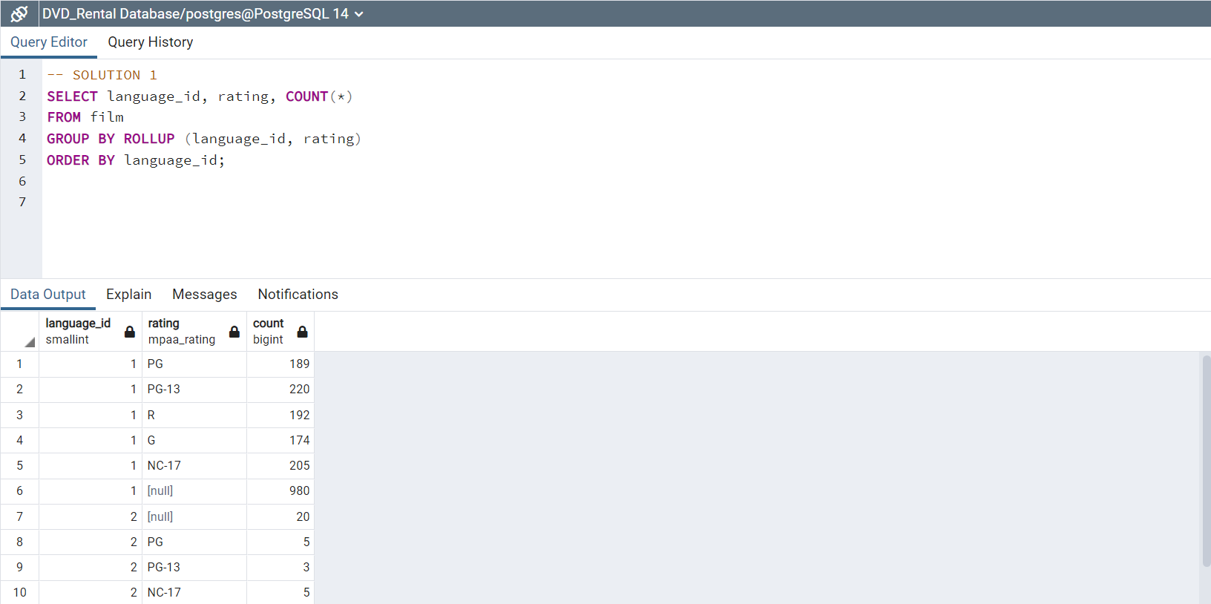
20) Select the language_id, rating and count the number of movies under each language_id, then cube on language_id and rating and sort the results by the language id.
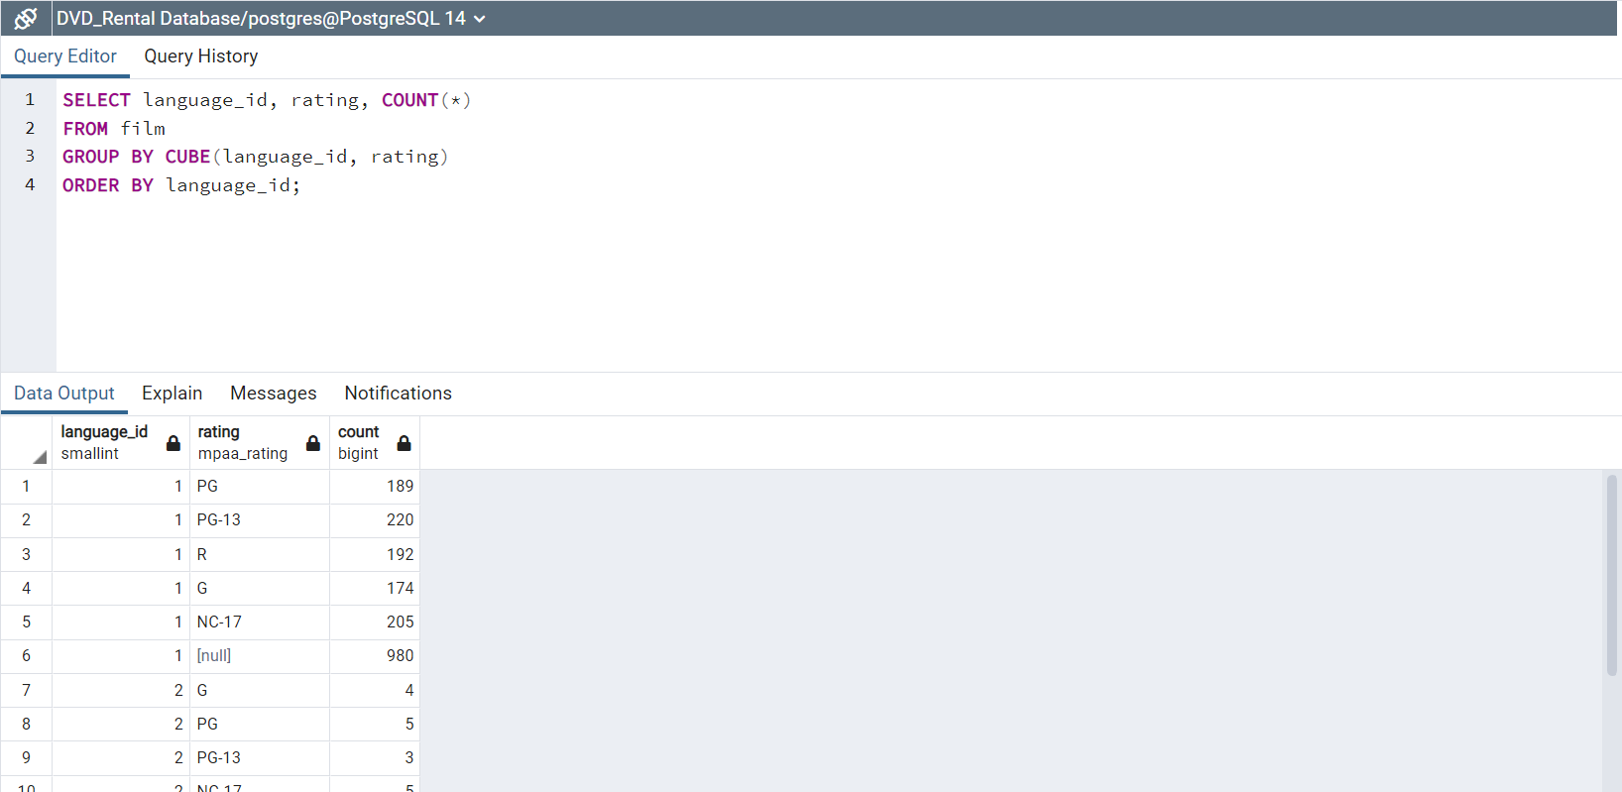
21) Select movie titles, rental_rates along with a new column that has the rental rate discounted 20%.
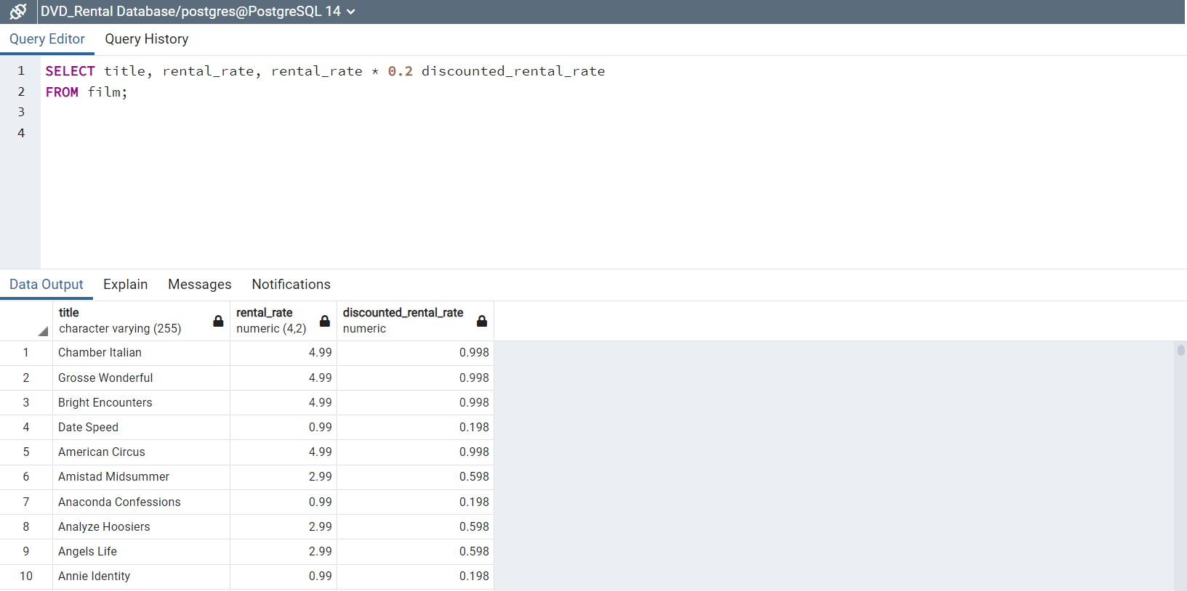
22) Select title, replacement_cost, rating, along with the maximum replacement cost under that rating.
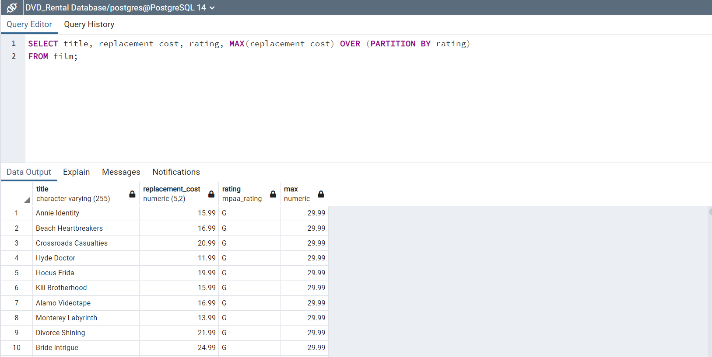
23) Select for every movie it’s title, replacement_cost, rating and the replacement_cost for the movie in the previous row in the same rating.
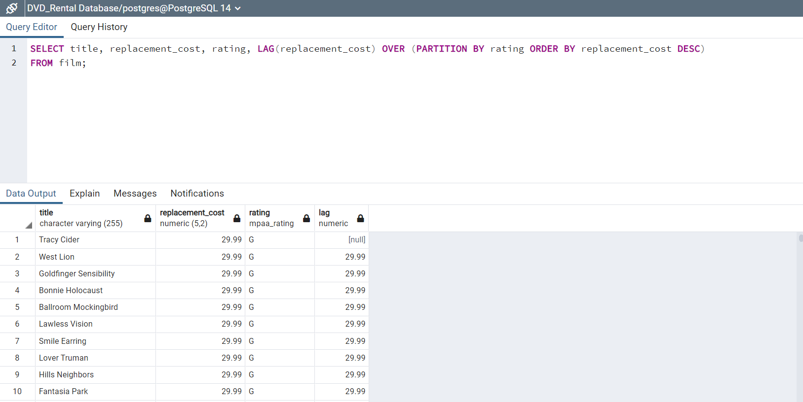
24) Select for every movie it’s title, replacement_cost, rating and the replacement_cost for the movie in the next row in the same rating.
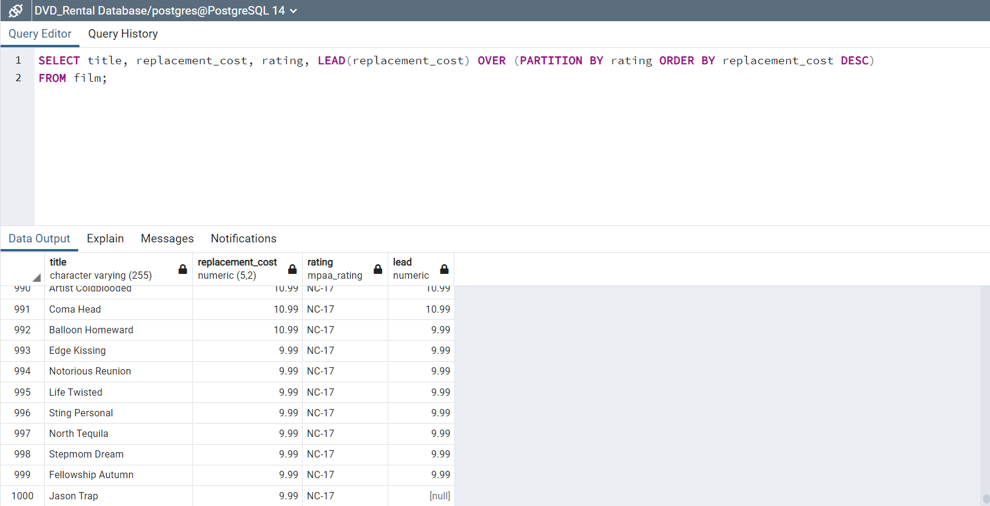
25) Group the rows in the film table into 4 buckets or 4 order groups.
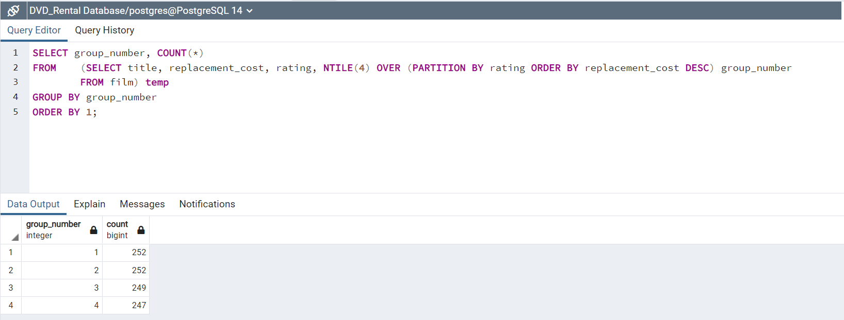
26) Select for each movie it’s title, rental_rate and the rental_rate for the next two rows partitioned by the language_id.
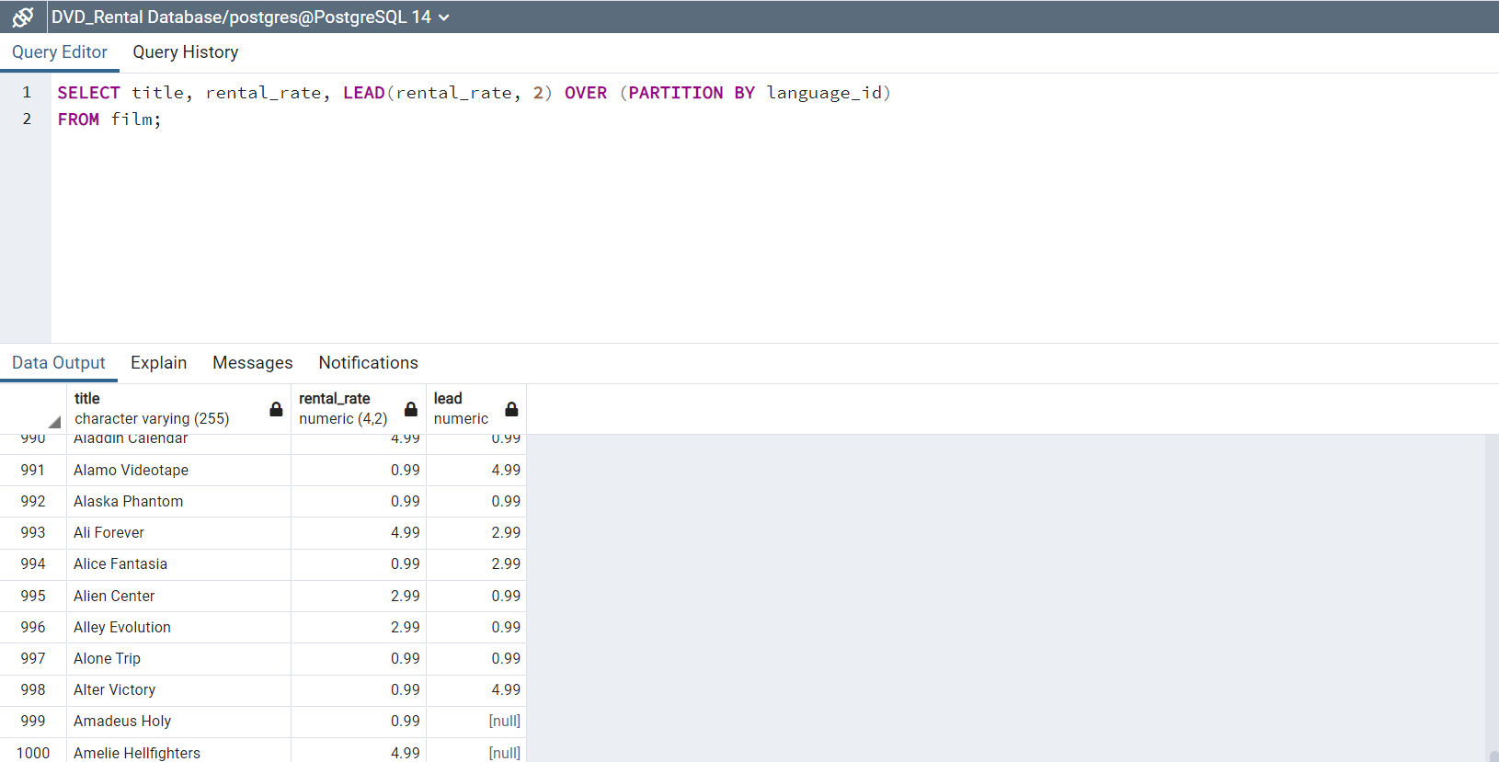
27) Select for each movie it’s title, rental_rate and the rental_rate for the two previous rows partitioned by the language_id.
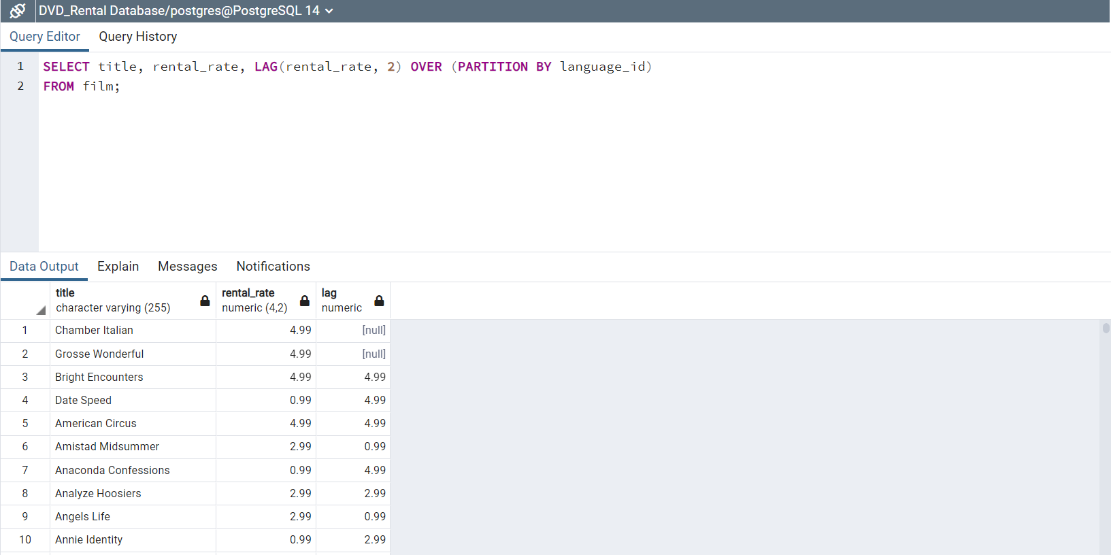
28) Show the rank by rating and order the results by rental_rate.
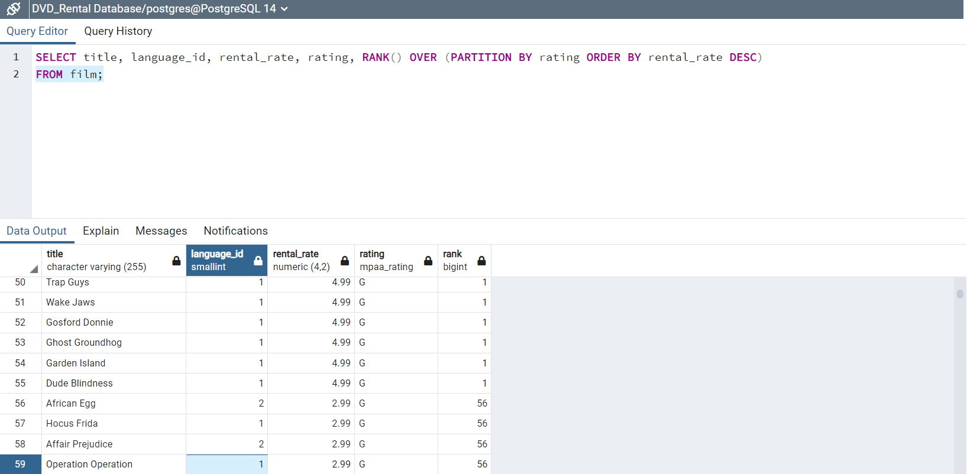
29) Show the percentage rank by rating and order the results by replacement_cost.
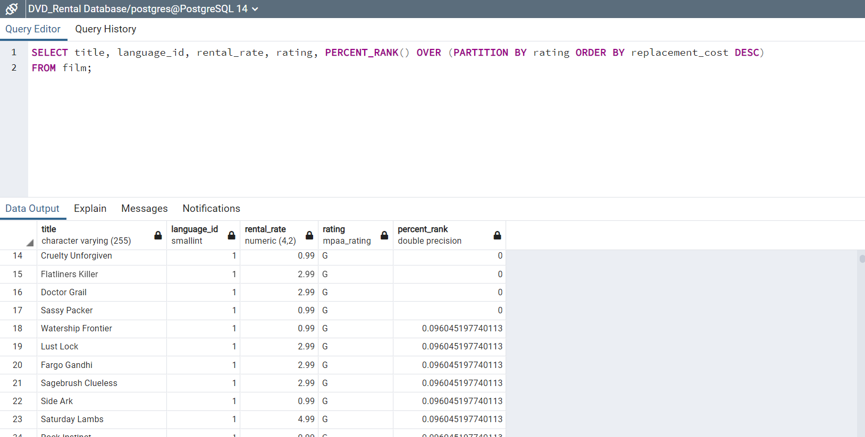
30) Create “temp_table” table with the WITH statement that has all the movies with titles that start with a ‘b’ or ‘B’. Then select all information from the “temp_table”.
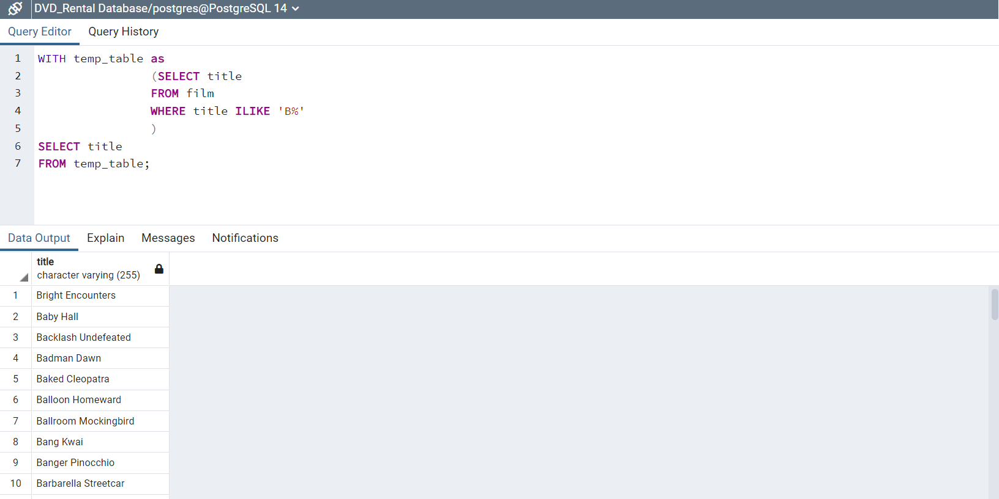
31) Select all the movies excluding those under ‘PG-13’ or ‘G’ ratings.
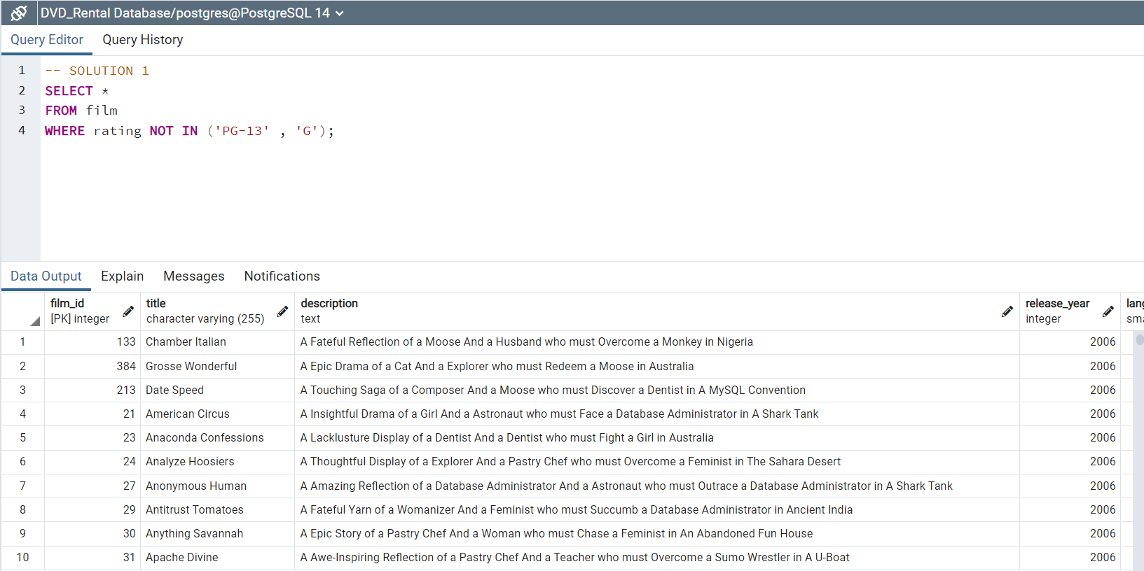
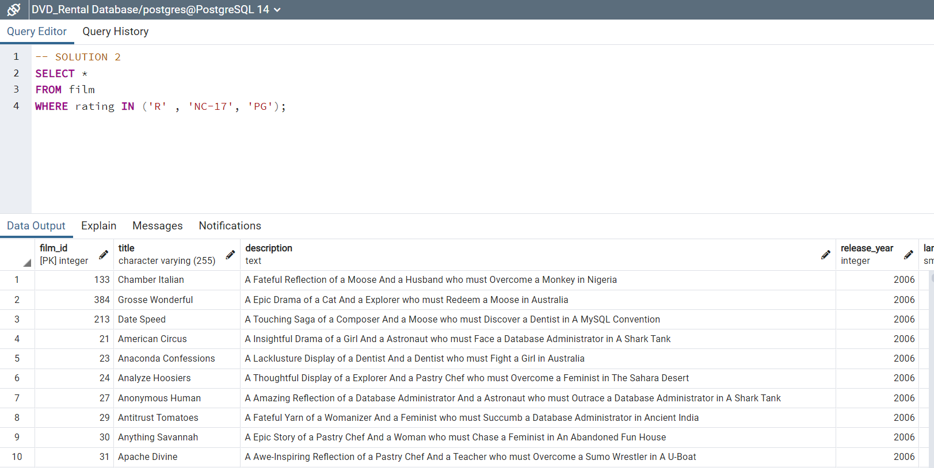
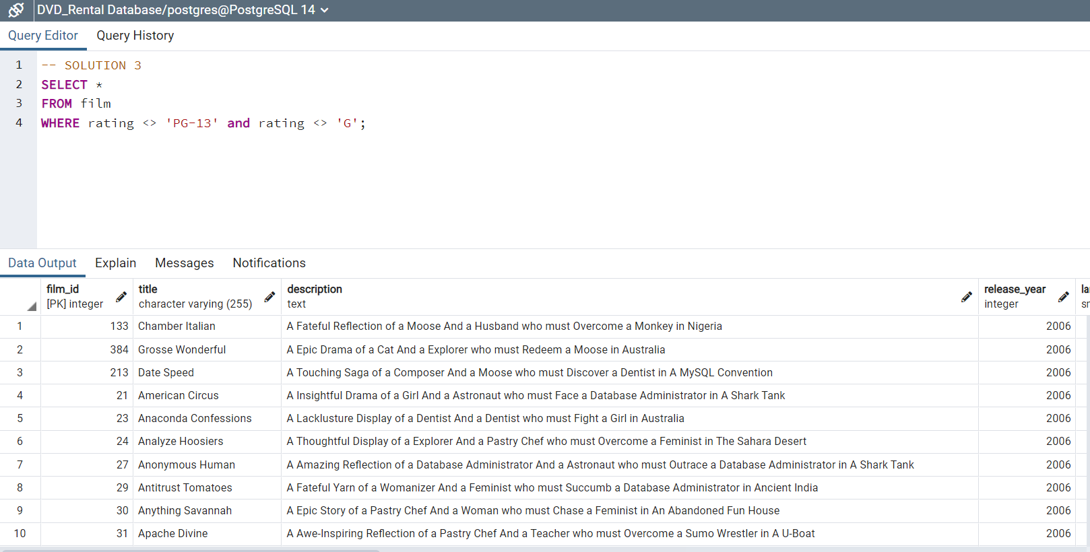
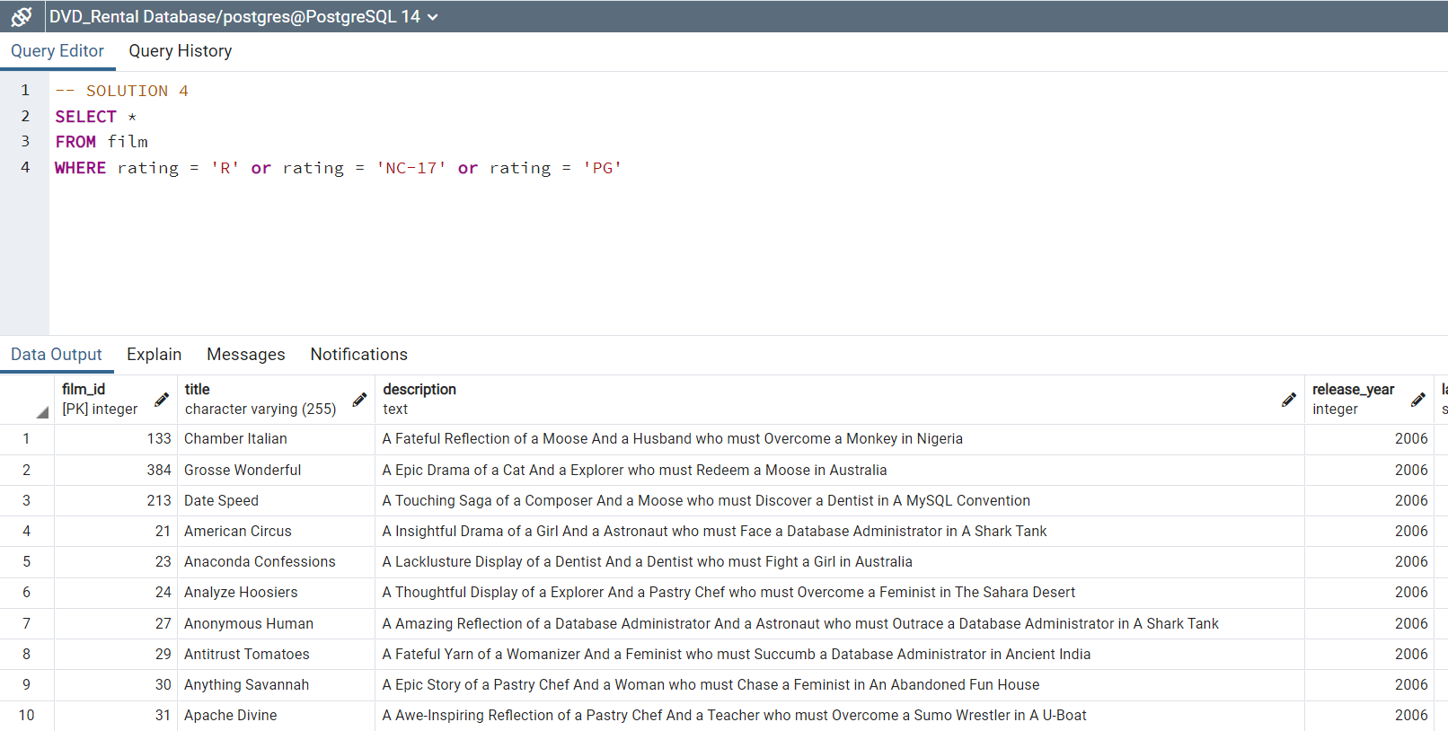
32) Select the actors with actor_id from 1 to 20.
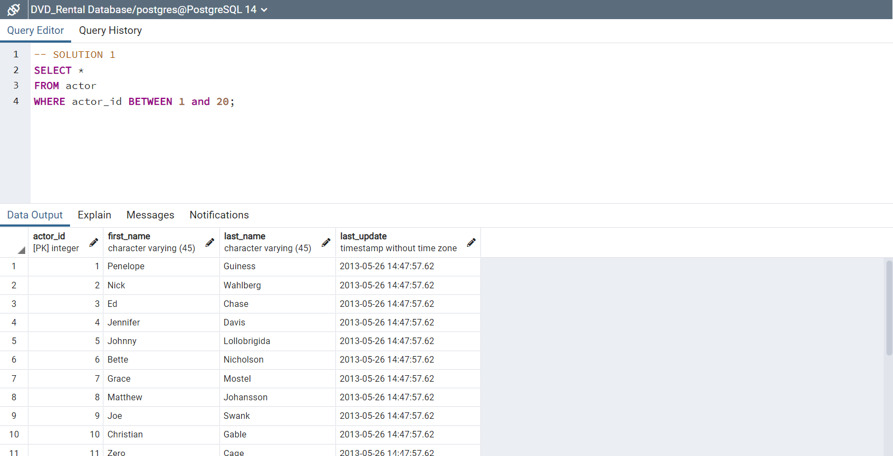
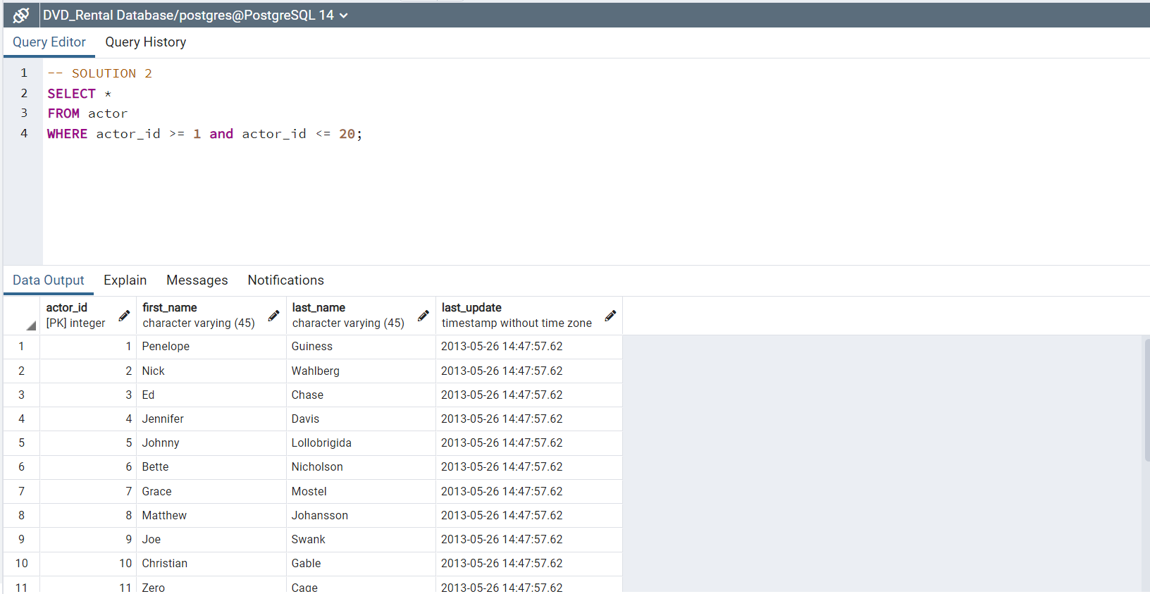
33) Select the actor’s first_names that have more than 5 letters.
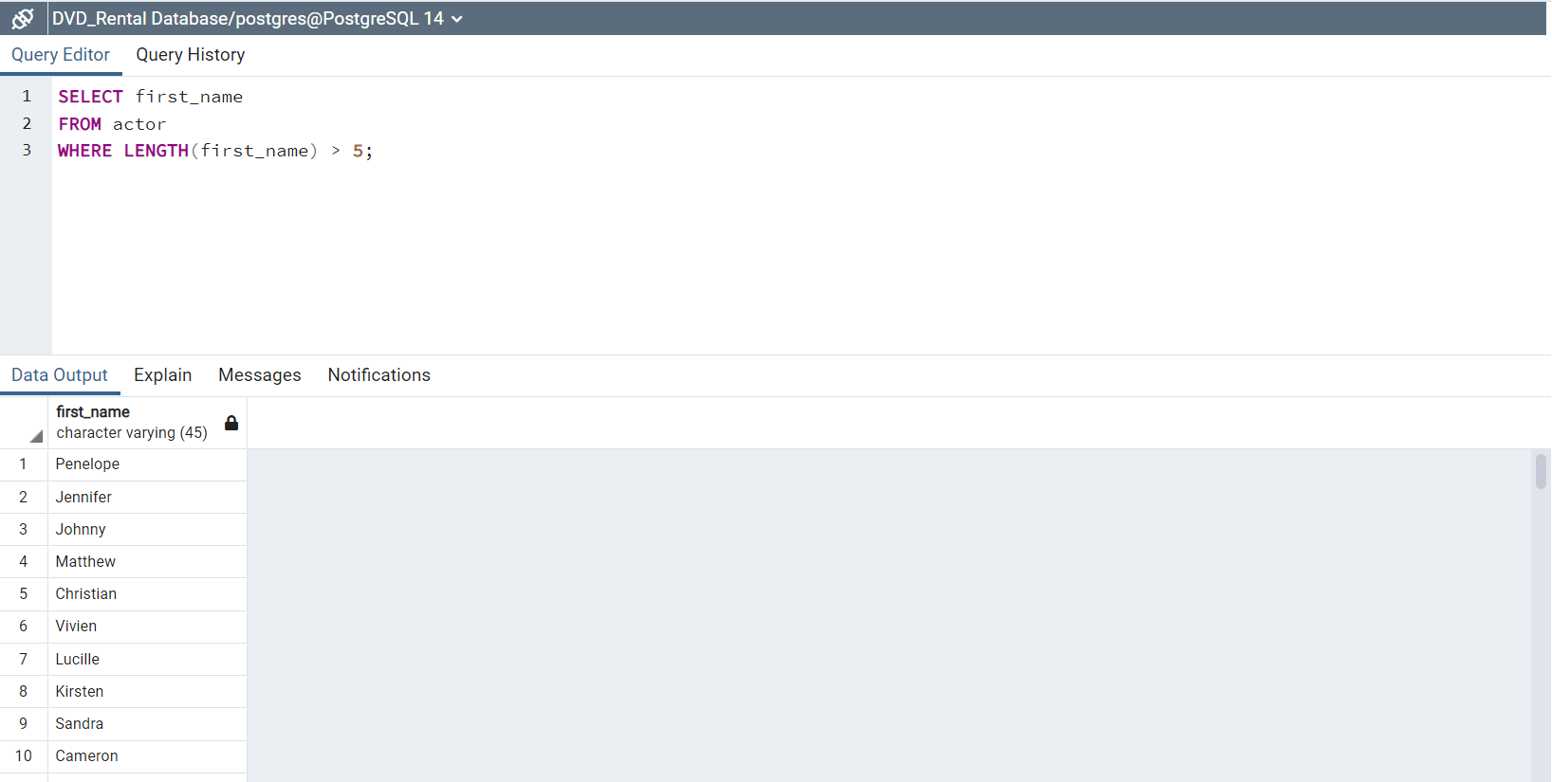
34) Select language_ids and language names that have movies in the film table with those language_ids.
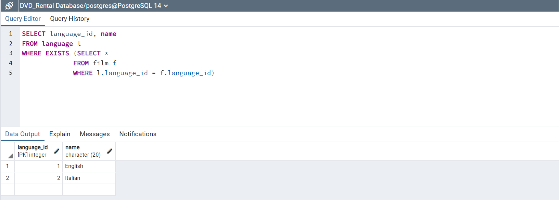
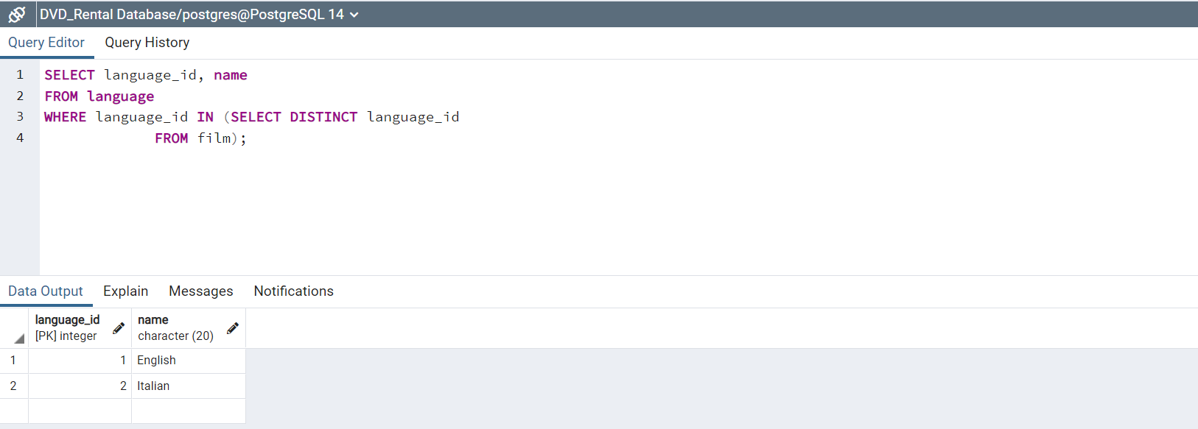
35) Select the first 5 rows in the actor table.
